 | USER REQUIREMENT SPECIFICATION
URS No. |  | Version no | 01
URS Title | Telesales Team Version 2
Department | BIO-BANK
Owner | Pallavi K

1. Introduction & Objectives
The goal is to develop a comprehensive CRM tool to manage the entire lead lifecycle—from initial capture through various stages like Lead, Appointment, Presentation, and SEF (Enrollment). The system must integrate seamlessly with automated landing pages, dialers for outbound calling, and the Stemcell application for field sales coordination.

2. Lead Management

2.1 Lead Capture & Distribution
- Automated Capture: Leads are captured from diverse sources (Facebook, Instagram, Website, Inbound Calls) and integrated via automation.
- Bifurcation: Automation trees must map leads to specific sources and mediums (e.g., Digital, Referral, Hospital) using Source and Medium IDs for performance tracking.
- Manual Creation: Agents must have a form to manually create leads with mandatory fields like Name, Phone Number, Medium, and Lead Source.

2.2 Duplication & Unique Identification
- Duplicate Check: A robust check against primary/secondary phone numbers and email IDs must be performed against existing data in the Stemcell app.
- Stemcell Migration: Every digital lead captured must automatically create a corresponding lead in the Stemcell app with a unique Lead ID.

3. Dialer Integration & Outbound Logic
- API Integration: Lead details are sent to a dialer for automated calling.
- Calling Priority (LIFO): Priority is managed via a LIFO (Last-In-First-Out) mechanism:
  - Priority 0: New Leads
  - Priority 1: Abandoned Calls
  - Priority 2: Callbacks
  - Priority 3: Churn (Not contacted/Ringing)
- Response Handling: The system must capture call logs, durations, recordings, and service operator codes (e.g., Ringing, Busy) to drive re-attempt algorithms

2.1 Data exchange with dialer
>Lead details should be sent to the dialer for auto dialler calling via API from CRM.

1.1st attempt dial within 1 minute of the lead capture in the operational hours.
2.Leads received in non -ops hours should be dialled in the next morning.
3. Once a lead is dialled the number of calls made should be tracked via a call log update sent from the dialer to CRM.
4.Calls that are not answered due to no response or busy have to be captured via dialer with the service operator codes (Ringing,Busy,Switched off, Not reachable etc). This data is used to make reattempts/churn based on an algorithm.
5.Every call log attempts made should be captured as a call log and the call counter needs to be updated with the no. of attempts.
Lead dispositions logic - which are updated in the dialer should be mapped in the CRM tool and the further automations on Churn/Invalid leads categorization needs to be performed.(except for not reachable after 7 attempts).

Callback mechanism - Leads which are updated as callback, the calls should be dialed as per the callback date and time which needs to be integrated with the dialer.

Call counter logic - Every call log attempts made should be captured as a call log and the call counter needs to be updated with the no.of attempts.with the lead field and an automation should be performed to change the lead stage to Invalid for “not reachable after 7 attempts” leads.

4. Lead Stages & Workflow

Stage | Description
Lead | Active leads pending churn or first contact.
Invalid | Leads that are non-responsive after 7 attempts or marked as irrelevant (e.g., Wrong Number, Already Delivered).
Appointment | The stage where an agent schedules a presentation for themselves (Telesales) or a field representative (Sales/Personal).
Presentation | After a presentation is completed, agents update statuses to Follow-up, Dropped, or Enrolled.
SEF | The enrollment stage, triggered by a CRM-generated event in the Stemcell app.

2. Lead Management

2.1 Lead Capture & Distribution
- Automated Capture: Leads are captured from diverse sources (Facebook, Instagram, Website, Inbound Calls) and integrated via automation.
- Bifurcation: Automation trees must map leads to specific sources and mediums (e.g., Digital, Referral, Hospital) using Source and Medium IDs for performance tracking.
- Manual Creation: Agents must have a form to manually create leads with mandatory fields like Name, Phone Number, Medium, and Lead Source.

2.2 Duplication & Unique Identification
- Duplicate Check: A robust check against primary/secondary phone numbers and email IDs must be performed against existing data in the Stemcell app as existing logic.
- Stemcell Migration: Every digital lead captured must automatically create a corresponding lead in the Stemcell app with a unique Lead ID.

3. Dialer Integration & Outbound Logic
- API Integration: Lead details are sent to a dialer for automated calling.
- Calling Priority (LIFO): Priority is managed via a LIFO (Last-In-First-Out) mechanism:
  - Priority 0: New Leads
  - Priority 1: Abandoned Calls
  - Priority 2: Callbacks
  - Priority 3: Churn (Not contacted/Ringing)
- Response Handling: The system must capture call logs, durations, recordings, and service operator codes (e.g., Ringing, Busy) to drive re-attempt algorithms.
- Churn intervals will be 3 hours.
- 10am - 8.59pm (Business hours) For Inbound calls received from the outcalled DID on non business hours should have a recorded message.

- Outbound call activity fields that need to be passed from dialler to CRM.

Display Number
Call date and time
Call Duration
Owner
Status (Dialler status)
Call Origin
Provider
Raw Call Status (From service provider)
Lead Status (CRM tool lead disposition)
Call Notes
Call Recording

- Inbound -
- Integrations are needed for Inbound, Digital Inbound leads with the tollfree IVR and the DID’s.
- Leads need to be captured as other sources and should go through the same dialing process.
- Calls that are received in non -ops hours for inbound/digital inbound should be captured as an abandoned call and leads should be dialed (outbound) next morning.
- Call recording should be available for Inbound log.

- Lead Owner -
- At lead level the owner is “admin”, and once at an appointment level it is assigned to the owner who creates the appointment.
- Leads are directly picked for autodialer from the pool of leads stored under the “admin” user.
- Provision to change the owner/assigned RE/lead details of appointment (either partially or totally) is required under admin access as and when needed.
Lead Sources & Medium

Medium | Lead source
Digital | Digital - CS Referral
Digital | Digital - Facebook
Digital | Digital - Facebook Inbound
Digital | Digital - Google Inbound
Digital | Digital - Inbound
Digital | Digital - Justdial
Digital | Digital - Nitro
Digital | Digital - SEM
Digital | Digital - Website
Digital | Digital - Website Inbound
Digital | inbound call
Digital | Digital - Instagram
Hospital | Digital - Hospital
Digital | Digital - Webinar
Digital | Digital - NIPT / PNS
Referral | Digital - Refer A Friend Lead
Referral | Digital - Referral RCS
Referral | Digital Referral
Referral | Digital-Rainbow Referral
Referral | Refer a friend lead
Referral | Referral EC

Lead Medium
Digital
Referral
Hospital
Partners
FMR

4. Lead Stages & Workflow
Stage | Description
Lead | Active leads pending churn or first contact.
Invalid | Leads that are non-responsive after 7 attempts or marked as irrelevant (e.g., Wrong Number, Already Delivered).
Appointment | The stage where an agent schedules a presentation for themselves (Telesales) or a field representative (Sales/Personal).
Presentation | After a presentation is completed, agents update statuses to Follow-up, Dropped, or Enrolled.
SEF | The enrollment stage, triggered by a CRM-generated event in the Stemcell app.

5. Key Functional Features
- Dynamic Forms: Agents use dynamic forms for lead status updates, appointment creation (integrating hospital/doctor DB and RE availability), and presentation outcomes.
- Task Management: Automatic task creation for appointments and follow-ups, including email notifications 15 minutes prior to scheduled events.
- Activity History: A real-time log capturing owner changes, call activities, WhatsApp messages, and stage transitions.
- Advanced Search & Export: Users can filter, search (using if/else logic), and bulk-update leads via CSV or manual selection.

6. Reporting & Dashboards
The CRM will feature real-time dynamic reports integrated with dialer and Stemcell data. Key reports include:
- Daily Lead, Appointment, PPT, and SEF performance.
- Source and Campaign-wise tracking.
- Agent productivity and missed follow-up reports.
- MOM (Month-over-Month) comparison dashboards.

7. User Roles & Access Control
- Telesales Agents: View-only access to assigned leads; restricted editing of lead fields.
- Managers: Access to all leads, reports, and limited lead field editing.
- Admin: Full access to all fields, user creation, automation modification, and system failure notifications.

8. Lead Capture & Management

8.1 Multi-Channel Lead Ingestion
Leads shall be captured via landing pages (FB, Instagram, Website, etc.) and direct channels (DID, Toll-free, Inbound).
- Bifurcation Logic: Automation trees must map leads based on Source ID and Medium ID to track campaign performance.
- Mandatory Lead Mediums: Digital, Referral, Hospital, Partners, FMR.

8.2 Manual Lead Creation
Agents require a manual entry form with the following mandatory (*) and optional fields:
- Customer Info: First Name*, Last Name, Email, Phone Number*, Alt Email/Mobile.
- Source Info: Source ID, Medium ID, Medium*, Lead Source* (Dropdown), Lc_Campaign Name/Type.
- Medical/Sales Info: Pregnancy EDD (Calendar: no backdating), Interested Products (Bio Bank, Diagnostics, Biologics, Others), Referrer CRM Number.
- System Info: Owner (Defaulted to user), Lead Status (Default: "New Lead").
- Below fields need to be added while creating the manual lead.

First Name*
Last Name
Email
Phone Number *
Source id
MediumId
Medium *
Lead Source * (Drop down of lead sources)
Pregnancy EDD (Calendar option shouldn't accept back dated)
Owner * (should be default based on the user)
Lc_Campaign Name
Lc_Campaign Type
Referrer CRM number
Lead Status (should be new lead by default)
Alternate Email ID & Alternate mobile no.
Interested products (Bio Bank, Diagnostics,Biologics,Others)

9. Data Integrity & Synchronization

9.1 De-duplication Logic
A bi-directional duplicate check with the Stemcell database is mandatory.
- Unique Identifiers: Primary/Secondary Phone Numbers and Primary/Secondary Email IDs.

9.2 Stemcell Migration
- Every Digital lead captured must trigger the creation of a corresponding lead in Stemcell.
- Requirement: The Stemcell Lead ID must be returned and updated in the CRM in real-time.

10. Dialer Integration (Outbound/Inbound)

10.1 Outbound Dialing Logic (LIFO)
Leads are pushed to the dialer via API.
- Priority 0: New Leads (Dialed within 1 minute during operational hours).
- Priority 1: Abandoned Calls.
- Priority 2: Callbacks (Triggered by LSQ date/time).
- Priority 3: Churn (LIFO based on call count: Not contacted, Ringing, etc.).
- Churn Intervals: 3 hours. Business hours: 10:00 AM – 8:59 PM.

10.2 Call Data Capturing
The following fields must sync from the Dialer to CRM:
- Logs: Call Date/Time, Duration, Owner, Status, Provider, Raw Call Status.
- Recording: URL/File of the call recording.
- Call Counter: Tracks the number of attempts.
- Auto-Invalidation: If Call Counter = 7 and status is "Not Reachable," automation must move Lead Stage to Invalid.

11. Lead Stages & Disposition Workflow

11.1 Lead Stages Defined
- Lead: Active leads pending contact or churn completion.
- Invalid: Leads that connect but are irrelevant, or reached 7 unsuccessful attempts.
- Appointment: Scheduled presentation (Personal or Telesales).
- Presentation: Post-explanation stage (Follow-up, Dropped, or Enrolled).
- SEF: Enrollment completed via Stemcell app.

11.2 Dynamic Disposition Forms
Agents will use dynamic forms that adapt based on the selected Lead Status:
- Language Barrier: Triggers a dropdown for specific dialects (Bengali, Telugu, etc.) and routes to the prescribed agent.
- Callback/Interested: Requires mandatory Date and Time fields (No backdating).
- Not Interested - Upfront: Requires a sub-disposition (e.g., Cost too high, Enrolled with competitor).
Lead dispositions - Will be updated by agents based on the conversation of the call (Few of the dispositions need to be updated automatically based on the integrations from the dialer and the call counter field).

Already Delivered
Appointment set
Language Barrier
Call back
Customer Hungup
Do not call
Duplicate lead
Enquiry only
Existing Cust Enquiry
Interested
Invalid number
Irrelevant Enquiry
New lead
Not contacted
Not interested - Upfront
Not Pregnant
Not reachable after 7 attempts
Rechurn for Marketing
Ringing
Wrong number
Enquiry for HPV
Enquiry for Perimenopause
Enquiry for Ovascore
Enquiry for NBS
Enquiry for STD
Enquiry for NIPT/PNS
Enquiry for Diagnostics
Existing Customer for other product
Not Right Party Contact
Not interested Early Pregnancy
Not interested After Content
Blank Calls
Sperm Donation
Order Complete - Aeroveda
Transferred to CS Team
Lifecell Employee
Enrolled with Lifecell already
International Clients

Lead Details - Journey of the lead needs to be captured and updated on the respective fields (real time) as and when the lead stage,lead status,sales status,appointment details,presentation details, follow up details,lead details and SEF details are updated/changed in the CRM/Dailler/Stemcell app.

First Name
Email
Phone Number
Source
Lead Score
Lead Stage
Owner
Country
State
City
Lead Origin (Landing Page Submission details)
Pregnancy EDD
SEF Date
Referrer CRM number
Branch code
Medium
Lead Status
MediumId
Source id
lead ID (From stemcell)
Appointment ID (From Stemcell)
Do Not Email (if Email is unsubscribed from customer)
Weeks Number
LDM Campaign Type ID
Campaign Type
Email Delivery Date
Lead Created Date and Time
Lead age
Call Counter
Created By
Modified By
Modified On
Engagement Score
Source Content
Source Campaign
Presentation Status
Sales Status
Consultation Type
RE Name
RE Code
Overall Status
Assigned RE
Appointment Set By
Appointment Created Date
Current Appointment Date and Time
Original Appointment Date
Customer CRM Number
Interested Product
Appointment booked for
Presentation done by
Presentation Date
Presentation date of sales
Follow Up Date and Time
Preferred Language

Lead dispositions/status that are considered as Valid lead/Lead stage.

Lead Stage | Lead Status
Lead | Call back
 | Customer Hungup
 | Enquiry only
 | Interested
 | Language Barrier
 | New Lead
 | Not contacted
 | Not interested After Content
 | Not interested Early Pregnancy
 | Ringing

Activity logs/History - Logs of the lead activities performed on the lead should be listed as a log along with the date and time stamp.
Below are the few samples that need to be captured.

Lead Capture: details.
Owner changed log
Lead stage changed log
Inbound Phone Call Activity
Outbound Phone Call Activity
Marketing whatsapp messages sent logs
Automation log
Lead status updated/changed log
Sales status received from stemcell
Presentation status updated log
Notes added from the agent
Activity forms submitted

Ref SS for Activity log

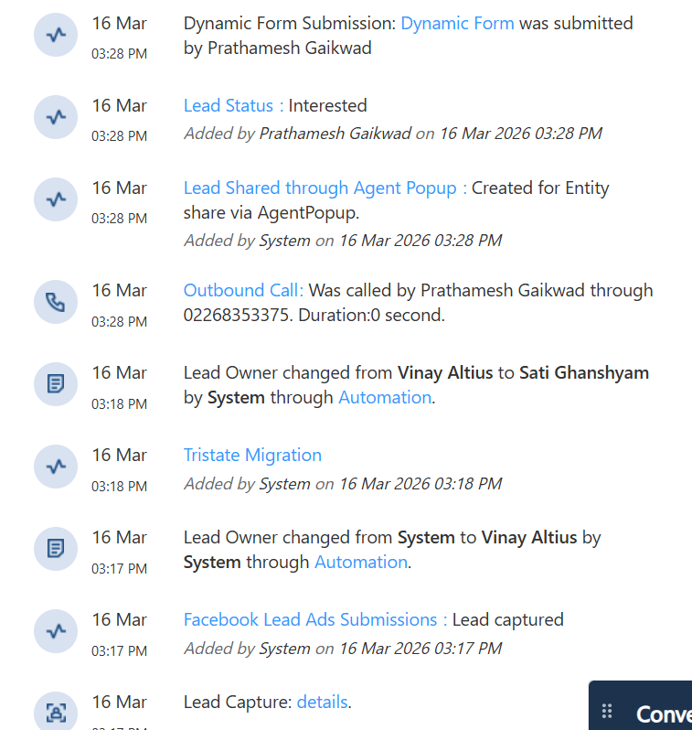

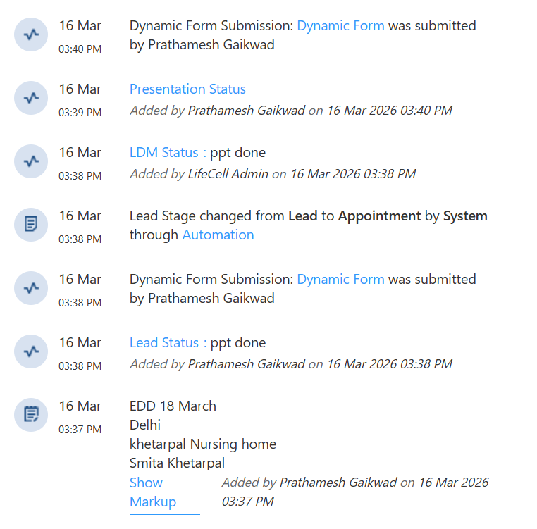

12. Appointment Creation

12.1 Personal (Sales) Appointment
- Flow: Agent selects "Sales" -> Consultation Type (Personal/Video).
- Integration: Must pull Hospital/Doctor DB from Stemcell.
- RE Mapping: Maps to specific Relationship Executives (RE) based on State/City/Pincode. If RE is unavailable, maps to their Manager.
- Output: Generates a unique Appointment ID in Stemcell.

12.2 Telesales Appointment
- Flow: Agent selects "Telesales" -> Preferred Language.
- Availability Check: System checks the creating agent’s leave calendar.
- Locking: Agents cannot modify appointment fields once an ID is generated. Only Admins can change lead stages post-appointment.

13. Presentation & SEF

13.1 Presentation Outcomes
- Presentation Done: Updates Presentation Date. Leads to Follow-up, Dropped, or Enrolled.
- Follow-up Push: If "Yes," allows selection of Hospital/Doctor and pushes data to RE.
- Dropped: Requires Dropped Reason (e.g., Doctor not recommended, Non-serviceable).
- Presentation Not Done: Statuses include "Missed by Client," "Missed by RE," or "Rescheduled."

13.2 SEF (Enrollment)
- Final conversion stage triggered by Stemcell.
- Data Points: SEF Date, Customer CRM Number, Plan Details (ASF, OTP, LTP, LifeCell Gold).

14. Reporting & Admin Tools

14.1 Dashboard Features
- Search: Filter by Phone, Email, Lead ID, or Appointment ID.
- Bulk Actions: Upload, Update, Delete, or Change Lead Owners (Admin only).
- Activity History: Chronological log of owner changes, call activities, WhatsApp logs, and stage transitions.
14.2. Lead dashboard -

- Filter options to select view and export the data via the lead fields.
- Customised search option to select view and export data with lead fields.
- Lead search option from phone number,email id,lead id and appointment id.
- Bulk lead update/upload/delete/change the lead fields via phone number,lead id or appointment id.
- Bulk lead creation option.
- Bulk lead deletion option.
- Lead fields change or modify options to the admin.
- DND option to mark the for unsubscribe the emails (Automation).

14.3. Task creation

- Task creation should be implemented in the appointment and presentation stage leads, for the cases where the appointments, presentations and follow up’s are scheduled.

- >For all the appointments, presentations and follow up’s are scheduled a task needs to be created with the unique task id.
- >For the cases where appointments are created the agent should get an email notification before 15mins of the appointment scheduled.
- Logics should be applied on the below scenario's
- 1.Reschuled appointments (based on the current appointment date).
- 2.Presentation scheduled cases.
- 3.Presentation follow up cases.

>Task status should be captured as per below
1.Pending
2.Overdue
3.Completed
4.Cancelled

> Automation should be created to integrate the same
>Separate tab access needs to be available to view update and export the leads with filters

14.4 Task Management
- Auto-Creation: Tasks created for every Appointment/Follow-up.
- Reminders: Email notifications 15 minutes prior to scheduled appointments.
- Statuses: Pending, Overdue, Completed,T Cancelled.
15. Lead stage - Invalid

Below lead status if updated the lead stage needs to be changed as Invalid.

For the lead status “Not reachable after 7 attempts”, the lead stage should be changed based on the call counter field which will be derived from the outbound call log activity from the dialler after 7 unsuccessful attempts.

No Churn/ repeat calls will be made once the lead status is invalid.

Lead Status
Already Delivered
Blank Calls
Do not call
Invalid number
Irrelevant Enquiry
Not interested
Not interested - Upfront
Not Pregnant
Not reachable after 7 attempts
Not Right Party Contact
Wrong number
Rechurn for Marketing
Transferred to CS Team
Duplicate lead
Enquiry for Diagnostics
Enquiry for HPV
Enquiry for NBS
Enquiry for NIPT/PNS
Enquiry for Ovascore
Enquiry for Sperm banking
Enquiry for STD
Existing Cust Enquiry
Existing Customer
Existing Customer for other product
Enrolled with Lifecell already

15.1. Appointment/Lead status updation form (Dynamic Form).
.
Appointment/Lead status updation form - Appointments and lead status are created/updated using the dynamic forms which needs to be developed in the CRM tool (Appointment/lead status updation form) which should have the below details for updating the lead status based on the call by an agent.

- >Lead status (with the dropdown of lead dispositions).
- >Owner (Owner of the lead, non editable field data should be prepopulated from owner field).
- >Pregnancy EDD (Calendar option should be available, shouldn’t accept the backdated entry)
- >Notes (Free text field).

Sample SS for reference -

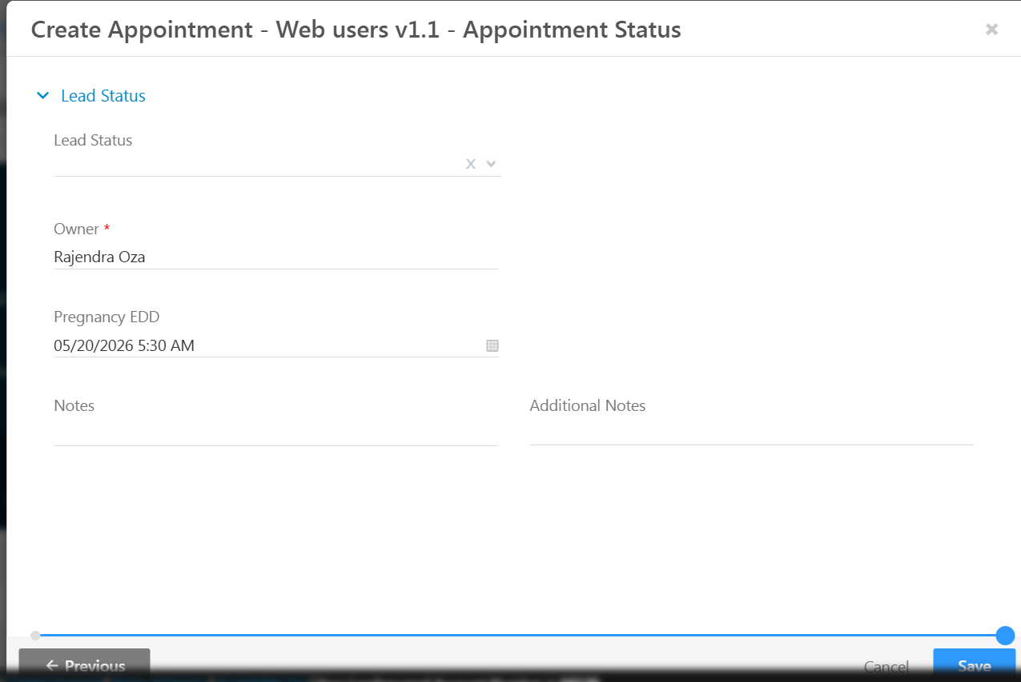

15.2. Language Barrier disposition/status -

If Language barrier is selected as lead disposition/status, below fields need to be appeared (An automation needs to be integrated based on the language selection and the leads needs to be assigned to the prescribed agent).

- >Lead status - Language barrier
- Language barrier* (Below details should be available in dropdown)
- Barrier Bengali
- Barrier Kannada
- Barrier Malayalam
- Barrier Telugu
- Barrier Malayalam
- Barrier Tamil
- Barrier Gujrati

- >Owner (Owner of the lead, non editable field data should be prepopulated from owner field).
- >Pregnancy EDD (Calendar option should be available, shouldn’t accept the backdated entry)
- >Notes (Free text field).

15.3. Call back disposition/status -

If Callback is selected as lead disposition/status, below fields need to be appeared and leads which are updated as callback, the calls should be dialed as per the callback date and time which needs to be integrated with the dialer and an automation needs to be integrated.

- >Lead status - Callback
- >Call back Date and time (Calendar option should be available, shouldn’t accept the backdated entry).
- >Owner (Owner of the lead, non editable field data should be prepopulated from owner field).
- >Pregnancy EDD (Calendar option should be available, shouldn’t accept the backdated entry)
- >Notes (Free text field).

15.4. Interested disposition/status -

If interested is selected as lead disposition/status, below fields need to be appeared and leads which are updated as Interested, the calls should be dialed as per the callback date and time which needs to be integrated with the dialer and an automation needs to be integrated.

- >Lead status - Interested
- >Call back Date and time (Calendar option should be available, shouldn’t accept the backdated entry).
- >Owner (Owner of the lead, non editable field data should be prepopulated from owner field).
- >Pregnancy EDD (Calendar option should be available, shouldn’t accept the backdated entry)
- >Notes (Free text field).

15.5. Not interested - upfront disposition/Status

If the not - interested - upfront is selected the below dropdown should be reflected and the same should be captured as a lead field
Not interested sub disposition*

Cost too high
Enrolled with competitor
Not Useful
Need more time & Information
Others

16. Lead stage - Appointment

Appointments can be of two types, personal and telesales.

>Personal appointment - These are the appointments that are fixed directly to the sales team/RE by a telesales agent after speaking to the customer and if the customer wishes to meet someone physically for taking the presentation.

>Telesales Appointment - These are the appointments that are fixed to the telesales agent himself as per the availability of the customer to take the presentation

16.1. Personal/Sales appointment creation flow

Page -1
- >Agent selects the lead disposition as an “appointment set” from the dropdown on the lead/appointment disposition page.
- >Option for selection of setting the appointment should be displayed
- Lead field - Sales or Telesales* (Drop down - Sales and Telesales)
- >Agent further selects “Sales”.
- >Lead field - Consultation Type (Personal,Telephone,Video).
- >Agent further selects “Personal”.
- >Owner (Owner of the lead, non editable field data should be prepopulated from owner field).
- >Pregnancy EDD (Calendar option should be available, shouldn’t accept the backdated entry)
- >Notes (Free text field).

Page - 2 :Adding Appointment details (the doctor hospital combination from stemcell needs to be integrated along with RE calender slot availability with the state city, Pincode mapping).

Lead fields to be made available

- Select state (Dropdown)
- Select City (Dropdown)
- Select Hospital (Dropdown)
- Select Doctor (Dropdown)
- Select RE (should be prepopulated based on the combination selected)
- Pregnancy EDD (Calendar option should be available, shouldn’t accept the backdated entry)
- Zip code (should be prepopulated based on the combination selected)
- Address (Free text)
- Appointment Date (Calendar option should be available, shouldn’t accept the backdated entry)
- Calendar slot of RE for the selected date along with the time slot to be reflected
- User (dropdown of Sales or Telesales)
- Notes (Free text).

Below SS for reference
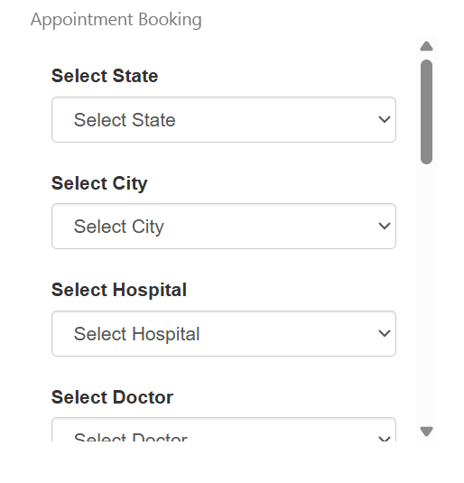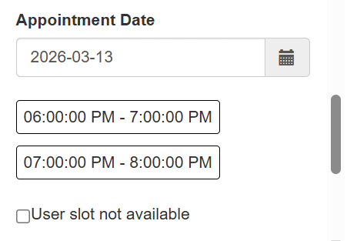

If the RE user slot is not available the appointment needs to be mapped to his manager on the stemcell app.
For every creation there should be an appointment id which needs to be generated on the stemcell app and get re-updated on CRM tool on a real time basis.

16.2. Appointment should be able to capture the below fields

- >Lead stage should be changed to “Appointment” and lead status should be “Appointment set” in the CRM.
- >Original appointment (Appointment scheduled date)
- >Appointment created date
- >Current appointment date (based on the update from RE, which is updated on the stemcell)
- >Appointment set by (field needs to be updated based on the user)
- >Consultation type (Needs to be captured, based on the type selected).
- >The status update made by the RE on the stemcell app needs to be updated as an activity log on CRM and the lead stage should be changed as per stemcell.
- >Owner of the lead should be changed based on the user created the appointment.
- >There should be an activity log of appointments created along with the below fields.
1.Lead status
2.Consultant Type
3.Appointment set for (Sales or Telesales)
4.Owner (User created the appointment.

17. Telesales appointment creation flow

17.1. Page -1
- >Agent selects the lead disposition as an “appointment set” from the dropdown on the lead/appointment disposition page.
- >Option for selection of setting the appointment should be displayed
- Lead field - Sales or Telesales* (Drop down - Sales and Telesales)
- >Agent further selects “Telesales”.
- >Lead field - Consultation Type (Personal,Telephone,Video).
- >Agent further selects “Telephonic” or “Video”.
- >Lead field - Preferred language should be displayed with below language option below (Dropdown).
- English
- Hindi
- Kannada
- Marathi
- Telugu
- Tamil
- Gujrathi
- Punjabi

- >Original appointment date (Calendar option should be available, shouldn’t accept the backdated entry).
- >Confirm slot - Yes/No (Dropdown)
- >Once the slot is confirmed the CRM tool should look for the owner “who is creating the appointment” (agents availability) as per the leave calendar of the agent. Only if the agent's calendar is available should it proceed for the next step by updating the lead field “Assigned RE/RE Available" as the same user who is creating the appointment.
- >The lead field “Assigned RE” should be mapped from the “RE available” field and it should be updated only for the cases of telesales appointments.
- >Owner (Owner of the lead, non editable field data should be prepopulated from owner field).
- >Pregnancy EDD (Calendar option should be available, shouldn’t accept the backdated entry)
- >Notes (Free text field).

17.2. Appointment should be able to capture the below fields

- >Lead stage should be changed to “Appointment” from “Lead” and lead status should be “Appointment set” in the CRM.
- >Original appointment (Appointment scheduled date)
- >Appointment created date
- >Current appointment date (based on the update from RE, which is updated on the stemcell)
- >Appointment set by (field needs to be updated based on the user)
- >Consultation type (Needs to be captured, based on the type selected).
- >The status update made by the RE on the stemcell app needs to be updated as an activity log on CRM and the lead stage should be changed as per stemcell.
- >Owner of the lead should be changed based on the user created the appointment.
- >There should be an activity log of appointments created along with the below fields.
1.Lead status
2.Consultant Type
3.Appointment set for (Sales or Telesales)
4.Owner (User created the appointment.

Below SS is for ref. for telesales appointment.

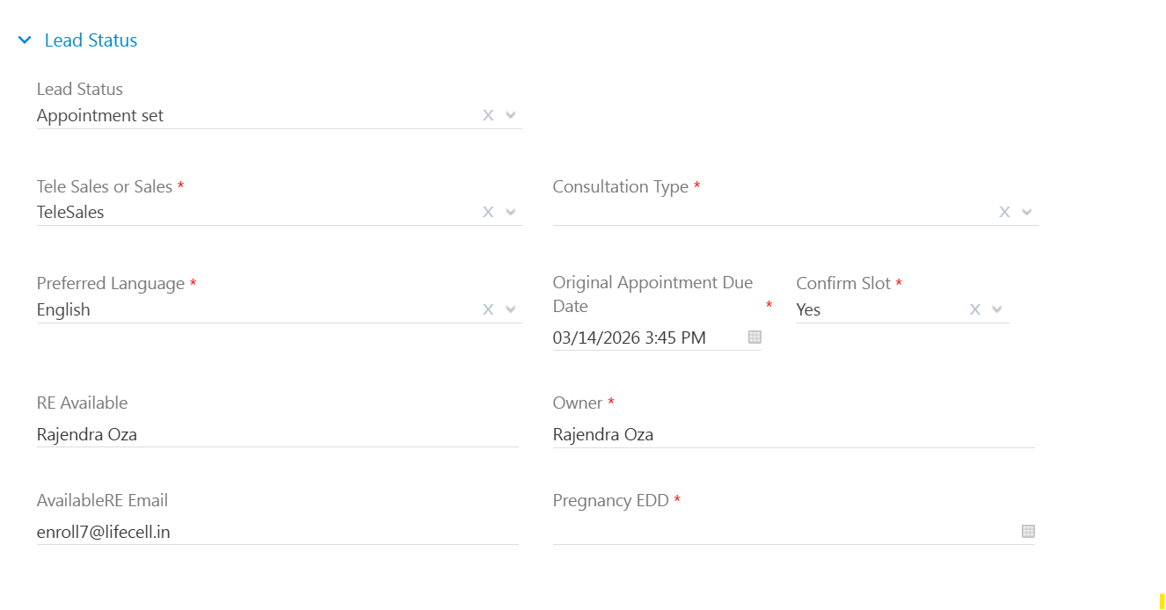

Note -
- Appointment ids which are created and updated should be unique and same as updated in stemcell app.
- The system shouldn’t allow a user to create the appointment twice on the same lead.
- The system should throw an error if agent is trying to create a new appointment on the already appointment created lead
- Assigned RE field update access should stay with the admin user role.
- Agents shouldn’t be able to update/change any of the appointment fields post appointment id generation.
- Change of lead stage from Appointment to lead or any should be with admin access role.

18. Lead stage - Presentation

Presentation is a stage where the agent updates the presentation status after completing the presentation based on conversation with the customer.

A dynamic form to update the presentation status needs to be created and integrated in the CRM tool.

18.1. Presentation status updation (Scenarios)

Presentation form (Follow up and push to Sales team)
Page -1
>Presentation status*
Dropdown* - Presentation done
Presentation not done

If Presentation done is selected
>Presentation date (field should be prepopulated with current date and time).
>Sales status*
Dropdown - Follow up call
Dropped
Enrolled
If a Follow up call is selected the below fields should appear.
1.Follow up date and time* (Calendar option should be available, shouldn’t accept the backdated entry).
2.Follow up Disposition* (Should have the below dropdowns)

- Follow up - Cold
- Follow up - Warm
- Unable to contact
- Will enroll after 1 week
- Will enroll after 2 week
- Will enroll after 3 week
- RE not connected the customer
- Personal PPT required from RE
- Only Whatsapp communication
- RE Duplicated
- In Touch With RE
- Connected on WhatsApp
- In Discussion / Not Yet Decided
- We'll Call Upfront
- >Push Follow up to Sales
- Dropdown - Yes
- No
- >Sales Push type - This field value should be derived from the sales status field above.
- >Pregnancy EDD - Date should be pre-populated from pregnancy EDD field
- >Follow up Date and Time (Calendar option should be available, shouldn’t accept the backdated entry).
- >Plan Type
- Dropdown - ASF
- OTP
- LTP
- Lifecell Gold
- >Notes* (Free text)

Ref SS for page 1 (Follow up push to sales scenario)

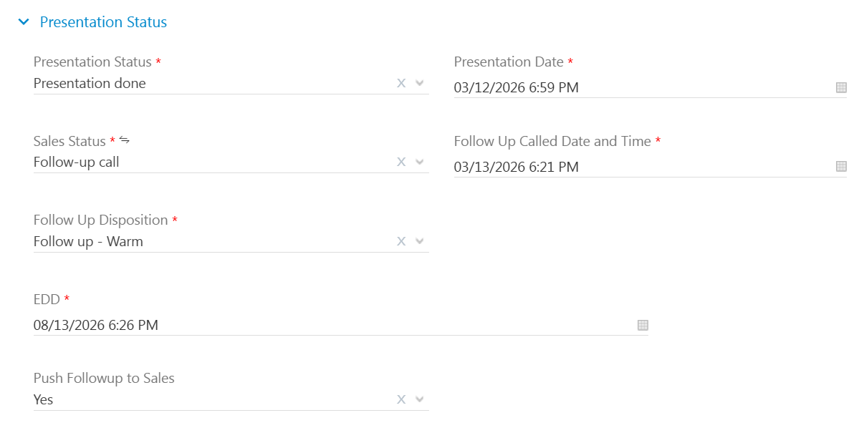

18.2. Page-2 (Follow up push to sales scenario)

Adding Hospital and Doctor combination details (the doctor hospital combination from stemcell needs to be integrated).
>Lead fields to be made available
- Select state (Dropdown)
- Select City (Dropdown)
- Select Hospital (Dropdown)
- Select Doctor (Dropdown)
- >Confirm Enrollment/ Follow up push*
- Dropdown - Yes
- No (If no is selected the follow up shouldn’t go to RE and it will stay with the telesales agent)
- If Yes is selected, below fields should be prepopulated based on the hospital doctor combination selected.
- State
- City
- Hospital
- Doctor
- Hospital id
- Doctor ID
- Centre
Ref SS of Page 2

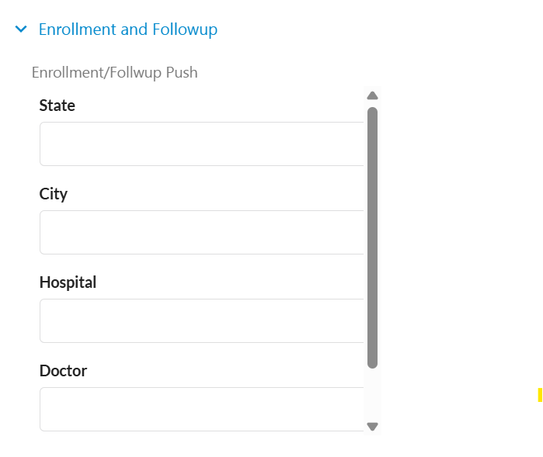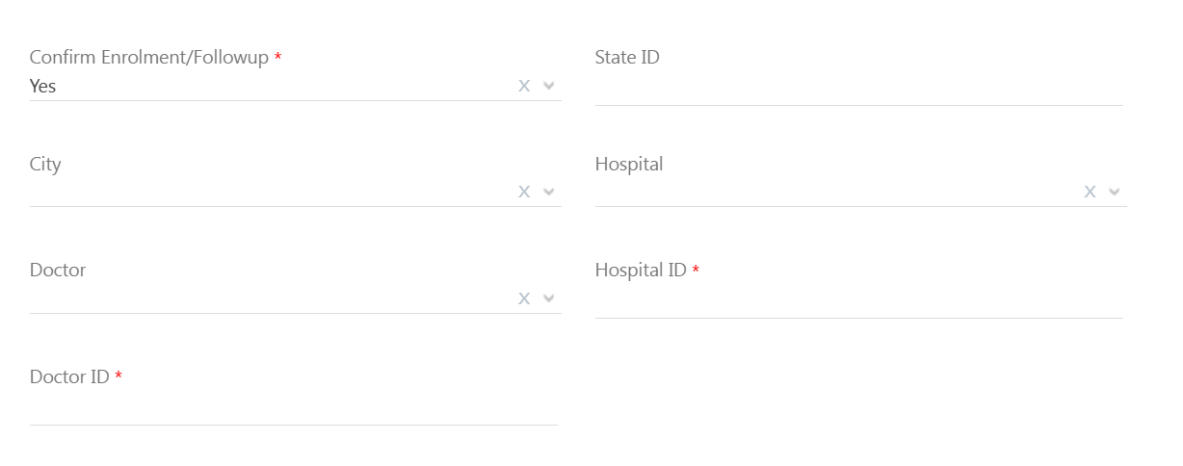

Note -
1.Presentation status can be updated by the agents multiple times based on the follow up’s, every time when the presentation status is updated logs should be captured in the activity log as “Presentation status Log” with the below fields in it.

Presentation Status Log
Sales StatusFollow-up call
Follow up date and time03/14/2026 05:27 PM
Presentation Date03/13/2026 05:27 PM
Appointment ID179880
State
Owner
Doctor ID
Hospital ID
EDD04/06/2026 04:58 PM
City
Push Enrolment to Sales
Notes
Confirm Enrolment / FollowupYes
Sales Push Type
Push Followup to Sales
Doctor
Hospital
Follow Up Called Date and Time
Follow Up DispositionFollow up

2.The presentation status updated by sales/RE on the stemcell app should be updated on the real time as an activity log and it should be mapped to the lead field “sales status” and “Overall Status”. This activity also can happen multiple times and logs should be posted every time as “Stemcell Log” with the below fields in it
Stemcell Log (Previous LDM status)
Lead ID
Appointment ID
Lead Gynaecologist
Appointment created date
Original Appointment due date
Current Appointment due date
Lead Status
TeleSales Or Sales
Presentation Status from RE
Sales status
Overall status
RE Name
Centre
Branch Code
RE Code
Check - in prior 1 hr
EDD
Notes
Lead Hospital

18.3. Presentation form (Enrollment push to Sales team)

Page -1
>Presentation status*
Dropdown* - Presentation done
Presentation not done

If Presentation done is selected
>Presentation date (field should be prepopulated with current date and time).
>Sales status*
Dropdown - Follow up call
Dropped
Enrolled
If an Enrolled is selected the below fields should appear.

- >Sales Push type - This field value should be derived from the sales status field above.
- >Pregnancy EDD - Date should be pre-populated from pregnancy EDD field
- >Plan Type
- Dropdown - ASF
- OTP
- LTP
- Lifecell Gold
- Notes* (Free Text)

Ref SS for page 1 (Enrollment push to sales scenario)
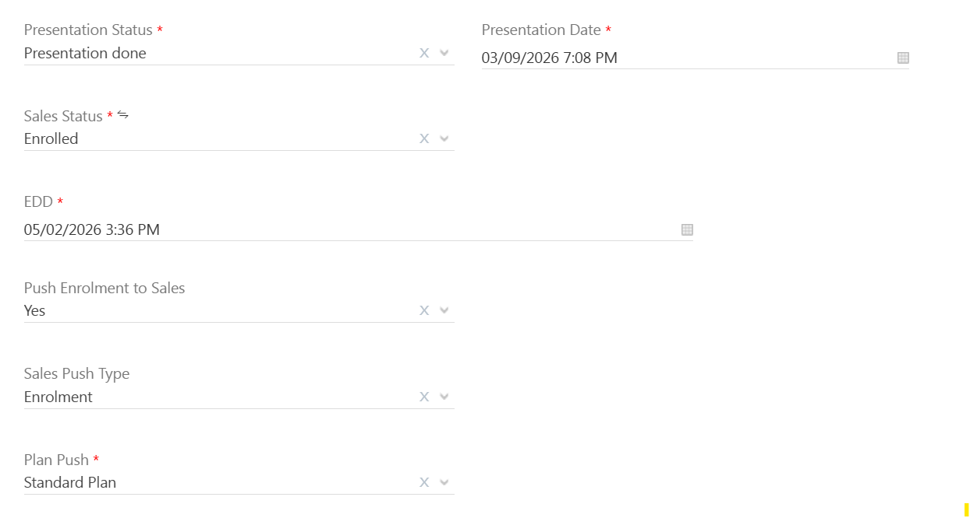

18.4. Page-2 (Enrollment push to sales scenario)

Adding Hospital and Doctor combination details (the doctor hospital combination from stemcell needs to be integrated).

>Lead fields to be made available
Select state (Dropdown)
Select City (Dropdown)
Select Hospital (Dropdown)
Select Doctor (Dropdown)

>Confirm Enrollment/ Follow up push*
Dropdown - Yes
No (If no is selected the follow up shouldn’t go to RE and it will stay with the telesales agent)

If Yes is selected, below fields should be prepopulated based on the hospital doctor combination selected.
State
City
Hospital
Doctor
Hospital id
Doctor ID
Centre
>Save page.
Ref SS of Page 2


Note -
1.Presentation status can be updated by the agents multiple times based on the follow up’s, every time when the presentation status is updated logs should be captured in the activity log as “Presentation status Log” with the below fields in it.

Presentation Status Log
Sales Status
Follow up date and time
Presentation Date
Appointment
State
Owner
Doctor ID
Hospital ID
EDD
City
Push Enrolment to Sales
Notes
Confirm Enrolment / Followup
Sales Push Type
Push Followup to Sales
Doctor
Hospital
2.The presentation status updated by sales/RE on the stemcell app should be updated on the real time as an activity log and it should be mapped to the lead field “sales status” and “Overall Status”. This activity also can happen multiple times and logs should be posted every time as “Stemcell Log” with the below fields in it
Stemcell Log (Previous LDM status)
Lead ID
Appointment ID
Lead Gynaecologist
Appointment created date
Original Appointment due date
Current Appointment due date
Lead Status
TeleSales Or Sales
Presentation Status from RE
Sales status
Overall status
RE Name
Centre
Branch Code
RE Code
Check - in prior 1 hr
EDD
Notes
Lead Hospital

.Presentation form (Dropped lead scenario)

Page -1
>Presentation status*
Dropdown* - Presentation done
Presentation not done

If Presentation done is selected
>Presentation date (field should be prepopulated with current date and time).
>Sales status*
Dropdown - Follow up call
Dropped
Enrolled
If a Dropped is selected the below fields should appear.
>Dropped reason* (Drop down)

Already Delivered
Cost too high
Demand for Higher Discount
Doctor not recommended
Enrolled with Competitor
Unable to establish contact
Customer cancelled online consultation
Concept
Already Enrolled with Lifecell
Never asked for Appointment
Registered for free gifts
Wants Free stemcells cover
Non serviceable area
Already preserved for 1st Baby
Not Decision maker/Third Party
High collection charges
Not comfortable with self collection
No symptoms so not required
Referral lead created
Duplicate done

>Sales Push type - This field value should be derived from the sales status field above.
>Pregnancy EDD - Date should be pre-populated from pregnancy EDD field
>Plan Type
Dropdown - ASF
OTP
LTP
Lifecell Gold
Notes* (Free Text)

Ref SS for page 1 (Dropped lead scenario)
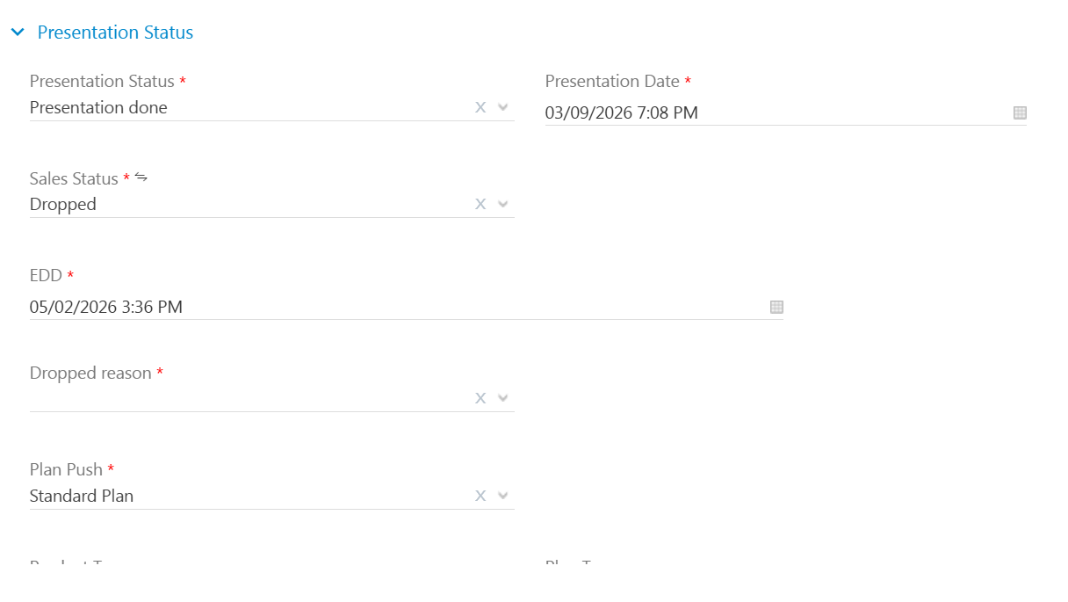

Page-2 (Enrollment push to sales scenario)

Adding Hospital and Doctor combination details (the doctor hospital combination from stemcell needs to be integrated).

>Lead fields to be made available
Select state (Dropdown)
Select City (Dropdown)
Select Hospital (Dropdown)
Select Doctor (Dropdown)

>Confirm Enrollment/ Follow up push*
Dropdown - Yes
No (If no is selected the follow up shouldn’t go to RE and it will stay with the telesales agent)

If Yes is selected, below fields should be prepopulated based on the hospital doctor combination selected.
State
City
Hospital
Doctor
Hospital id
Doctor ID
Centre
>Save page.
Ref SS of Page 2



.Presentation form (Presentation not done scenario)

>Presentation status*
Dropdown* - Presentation done
Presentation not done

If Presentation not done is selected
>Sales status* (Dropdown)

Unable to Contact
Rescheduled
Dropped
Missed by client
Cancelled by client
Missed by RE

Flow if the below disposition is selected

Unable to Contact
Rescheduled
Missed by client
Cancelled by client
Missed by RE

>EDD - Date should be pre-populated from the pregnancy EDD field.
>Sales push type
Dropdown - Follow up
Enrollment
>Follow up date and time (Calendar should be displayed along with the time stamp. Backdated dates shouldn’t be accepted)
>Plan Type
Dropdown - ASF
OTP
LTP
Lifecell Gold
>Notes* (Free text)
> Save

Flow if the Dropped is selected

>Sales status - Dropped
>EDD - Date should be pre-populated from the pregnancy EDD field.
>Dropped reason*
Drop down

Already Enrolled with Lifecell
Never asked for Appointment
Registered for free gifts
Wants Free stemcells cover
Dr not recommended
Non serviceable area
Already preserved for 1st Baby
Not Decision maker/Third Party
High Collection charges
Cost too high/Affordability
Cost too high Competitor

>Save

Note -
1.For presentation not done cases the lead status will be “Presentation not done”
2 If the lead selected as dropped the sales status should be updated as “Dropped” and the reason needs to be captured in a different lead field as “Dropped sub disposition”.
3.Activity log should be posted with the Dropped sales status and “Dropped sub disposition”.

19. Lead stage SEF

Lead stage SEF is the enrollment stage, the leads which are CRM generated on the stemcell application the details needs to be flow to CRM tool and the lead stage should be changed to ‘SEF’ on a real time basis.

The SEF details such as SEF date and time, customer CRM number,Plan details etc should be sent to CRM from stemcell as per the current logic via Stemcell log update and should reflect in the activity history.

Lead ID
Appointment ID
Appointment created date
Original Appointment due date
Current Appointment due date
Lead Status
TeleSales Or Sales
Presentation Status
Sales status
Overall status
SEF date
RE Name
Centre
Customer CRM number
Branch Code
RE Code
Presentation Date
Check - in prior 1 hrClicked
Notes
EDD

20. Reports and Export data dump

20.1.Export data dump

Export dump option should be provided to export the data dump with all and selected lead fields with filter/dropdown options to customize the date range.

Below are the few samples
Dropdown options to select the data via
1.Lead stage
2 Lead status
3.Lead medium
4.Lead source
5.Lead created date and time
6.Lead modified Date and time
7.Lead owner
8.Sales status
9.Assigned RE

We shall add the requirements as and when the UI is getting designed

Advanced search options

Lead fields and activities performed in the CRM should be able to search with “if,else,contains,between,is, is not” etc conditions.

Ref below sample SS for advanced search options

Criteria selection “And condition”
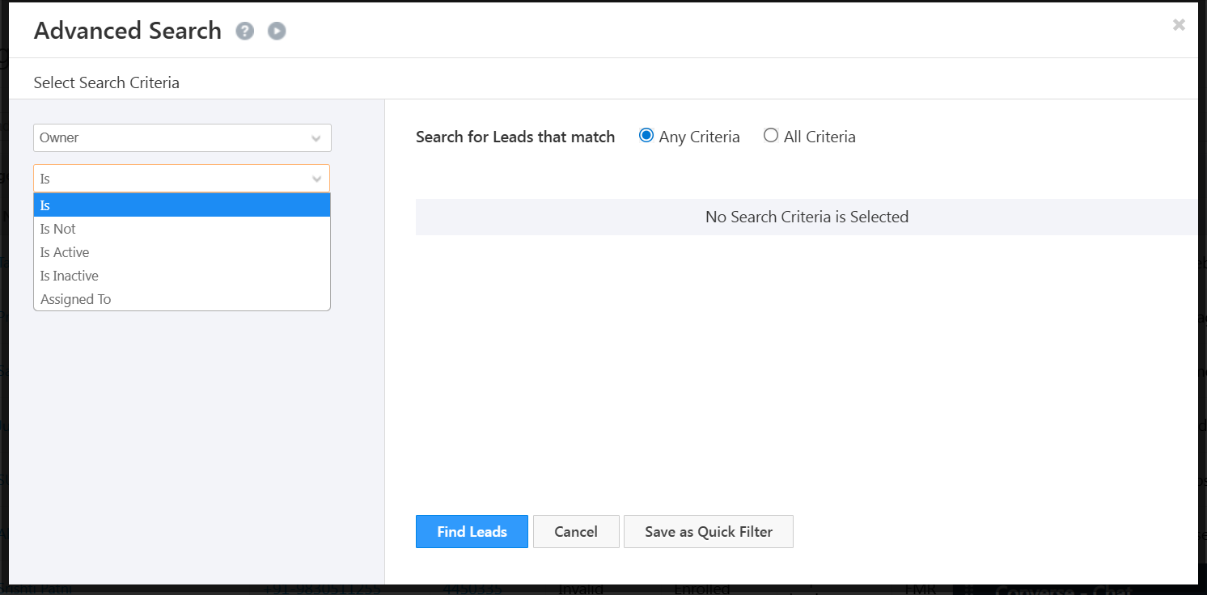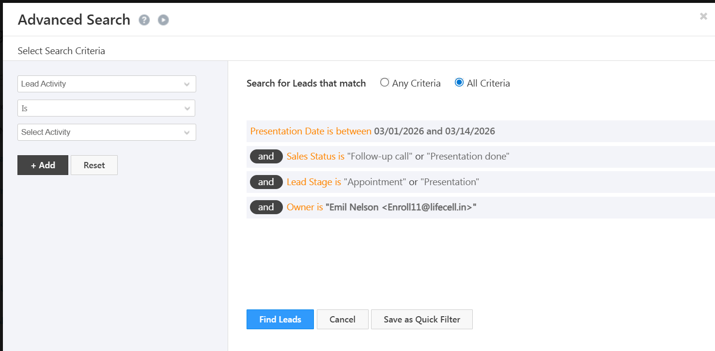

Or condition

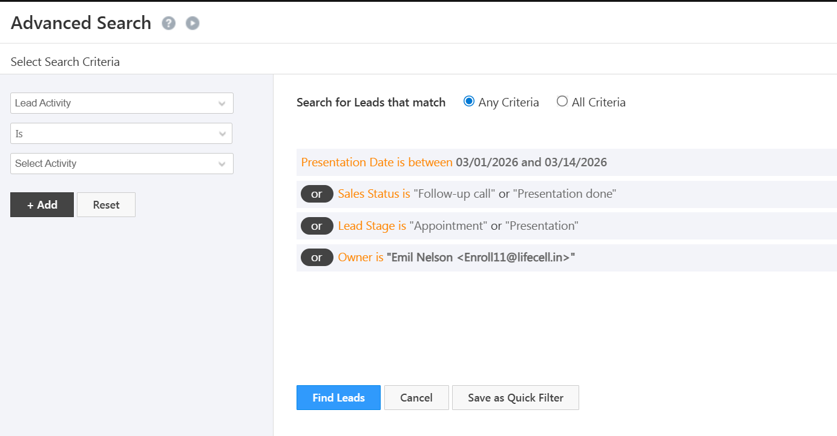
20.1. Reports

Below are reports which are needed to be built, all the reports should be dynamic (real time updated) and should be integrated with stemcell and the dailler along with the CRM tool.

Note-We have stated the report names, the logics and data requirements will be discussed once the UI is built.

1.Daily leads
2.Daily Valid lead
3.Daily Appointment
4.Daily PPT
5.Daily SEF
6.Active EDD with bucketing
7.Source and medium wise tracking
8.Source campaign wise tracking
9.Consolidated dashboard (date,month,source,lead,appointment,PPT and SEF).
10.Agent wise productivity report.
11.Agent follow up report basis EDD buckets.
12.Lead performance within the month and Lead performance on the modified date.
13.SEF created from within the month leads and from the previous month leads.
14.Review Dashboard & MOM comparison report
15. Missed follow up report (PPT).
16. Resubmission leads data (all sources).

Source
Total lead
Valid Lead
Connected - Valid
Valid - Not connected / churn
Connected Invalid
Not Connected Invalid
Valid%
APT
PPT
SEF
L2A%
L2P%
L2E%
P2E%

Stage -7 Dashboard UI and User roles

Dashboard UI
Agents should have the user-friendly UI to avoid manual tasks and access the upcoming appointments,PPT’s,follow up’s for the day/week/month.

Refer below SS for sample 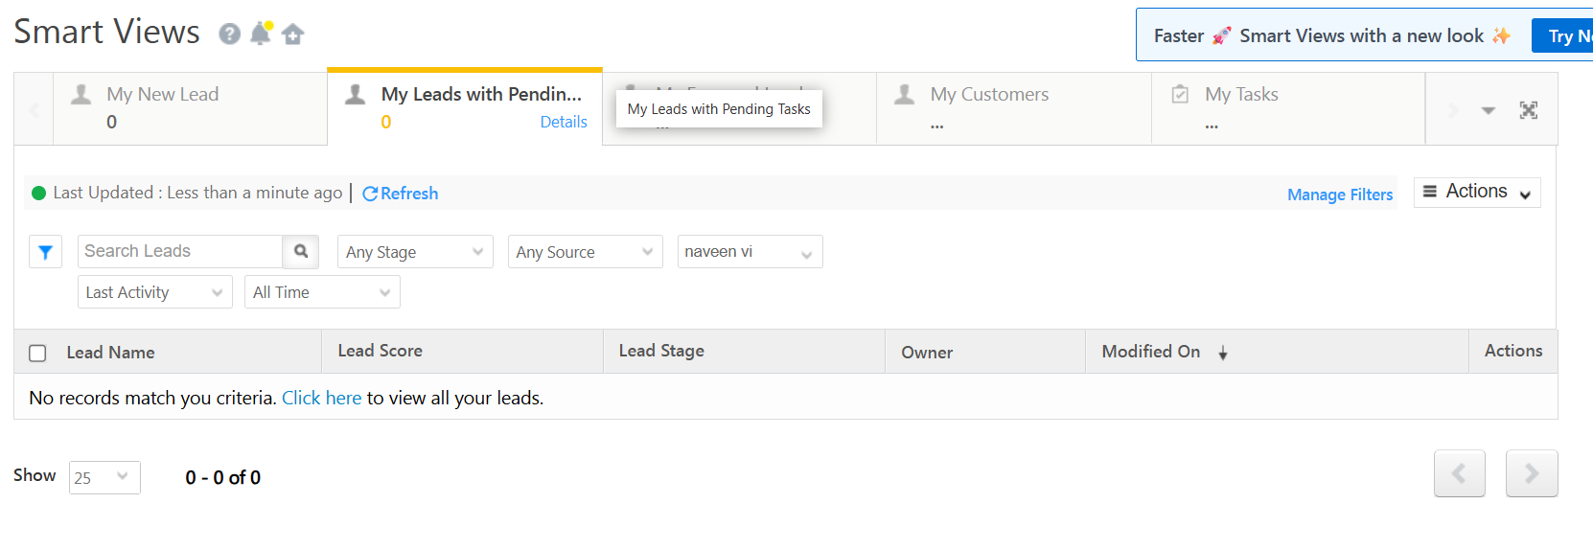
21. User Roles
Users should have the access based on the assigned roles below

Telesales agents -
>Should be able to view leads assigned only to their names.
>Access to reports and dashboard should be limited
>Access to edit lead fields should be restricted.
>Login and Logout time should be captured.
>Leave calendars should be made available

Manager roles -
>Should be able to access all the leads in the CRM
>Access to reports and dashboards should be given
>Limited access to Edit the lead fields
>Should be able to customize the dashboard to the agents.

Admin Roles -
>Should be able to access/edit/update any lead field
>Access to create new user
>Access to modify reports and dashboards
>Access to modify/change the automations.
>Access to add lead fields i.e Lead sources,dispositions etc
>Admin should be notified for any kind of API or Automation failures over an email.

22. Automation in use (All published and all Department)

Name | Trigger Type | Trigger Count | Last Published On | Status | Modified On(sorted descending) | Modified By
SA Appointment Set Sales/Telesales v2.1 | Sub Automation | 80302 | 03/20/2023 | Published | 04-02-2026 | naveen vi
Test Segment | Activity Added | 8 | 03/26/2026 | Published | 03/26/2026 | System
Push lead on lead create to Altius - 27-02-2026 | Lead Created | 16489 | 02/27/2026 | Published | 02/27/2026 | Aryan Admin
Call Back Date Time push to Altius (27-02-2026) | Activity Added | 27127 | 02/27/2026 | Published | 02/27/2026 | Aryan Admin
Source Facebook lead push to Altius (27-02-2026) | Lead Updated | 168739 | 02/27/2026 | Published | 02/27/2026 | Aryan Admin
LDM Push on dummy actvity -v12 | Activity Added | 235602 | 02/14/2026 | Published | 02/13/2026 | Aryan Admin
Landing Page Distribution - v2.16- Google search | Activity Added | 19277 | 02-11-2025 | Published | 02/13/2026 | naveen vi
Push to Genesys | Sub Automation | 462275 | 01/25/2022 | Published | 02-12-2026 | naveen vi
SA - Telecaller - v1 | Sub Automation | 157915 | 09/22/2023 | Published | 02-12-2026 | naveen vi
Lead distribution (NCNC) based on city v49.14 | Activity Added | 419987 | 01/25/2024 | Published | 02-12-2026 | naveen vi
SA genesys - North | Sub Automation | 7394 | 01/25/2022 | Published | 02-12-2026 | naveen vi
SA city distribution 2 v1 | Sub Automation | 3972 | 04-10-2023 | Published | 02-12-2026 | naveen vi
SA city distribution 1 v1 | Sub Automation | 193281 | 09/20/2023 | Published | 02-12-2026 | naveen vi
SCB - NR7 | Lead Updated | 20073 | 01/29/2026 | Published | 01/29/2026 | Arshad Safique
SCB P2E - Parallel - T1&T2 | Lead Updated | 8585 | 01/29/2026 | Published | 01/29/2026 | Arshad Safique
Push New Sales app list - auto-repush - v1.2 | Lead Created | 267630 | 01-08-2026 | Published | 01-08-2026 | Harshit Gupta
outbound call not connected - V1 - 13-08-2025 | Activity Added | 1181465 | 01-08-2026 | Published | 01-08-2026 | Aryan Admin
Lifecell - Diagnostics - New flow -07 Aug - V2 | Activity Added | 69542 | 12/30/2025 | Published | 12/30/2025 | Aryan Admin
MFine Derma disposition next action | Activity Added | 8 | 12/24/2025 | Published | 12/19/2025 | Aryan Admin
SCB P2E - Parallel | Lead Updated | 52829 | 12/16/2025 | Published | 12/16/2025 | Harshit Gupta
Send Lead Data On Lead Update | Lead Updated | 182020 | 11/19/2025 | Published | 11/19/2025 | Aryan Admin
SA -Genesys South | Sub Automation | 1666 | 01/26/2022 | Published | 10-09-2025 | Aryan Admin
Lead stage progression algorithm v25 v1.2 updated 19/03 | Activity Added | 1244780 | 03/20/2024 | Published | 10-06-2025 | Aryan Admin
SA - Language barrier | Sub Automation | 9952 | 03/20/2023 | Published | 10-06-2025 | Aryan Admin
Lead Status Owner Update - Clone | Activity Added | 487743 | 08/28/2025 | Published | 08/28/2025 | Aryan Admin
Post Presentation Update - V1 | Lead Updated | 104928 | 01/26/2024 | Published | 06/23/2025 | System
SCB - Digital Referral - Parallel | Lead Created | 139571 | 05/16/2025 | Published | 06/23/2025 | System
Lead stage update - Invalid after 7 attempts V2 | Lead Updated | 778143 | 06/20/2025 | Published | 06/20/2025 | Aryan Admin
New Lead | Invalid Counter=0 V1 | Lead Created | 136801 | 05/21/2025 | Published | 05/21/2025 | Aryan Admin
Copying Campaign parameters to system fields v 7 | Lead Created | 142703 | 05-10-2025 | Published | 05-10-2025 | System
Whatsapp Message Notification to User V-Test | Activity Added | 4072 | 04-07-2025 | Published | 04-07-2025 | System
Spermscore Leads Distribution-v16 | Lead Created | 8560 | 01-02-2024 | Published | 03/22/2025 | naveen vi
Manual Lead Push to Dialer - 2025 | Lead Updated | 35545 | 03/19/2025 | Published | 03/19/2025 | System
Genomescope Lead share v5.3 | Activity Added | 1931 | 01/25/2024 | Published | 03/17/2025 | naveen vi
Genomescope Lead share v5.2 | Activity Added | 4979 | 03/26/2024 | Published | 03/17/2025 | naveen vi
Appointment/LDM activity fields' update on lead fields/SMS v7.6- updated V2 | Activity Added | 650591 | 02/18/2025 | Published | 02/18/2025 | System
AreoVeda Leads Distribution-v2.1 | Activity Added | 9813 | 09/25/2024 | Published | 01/27/2025 | naveen vi
Mfine Derma Automation V4 - Clone | Activity Added | 48 | 01/21/2025 | Published | 01/21/2025 | System
Lead Status: Update follow up date | Activity Added | 412488 | 01-08-2025 | Published | 01-08-2025 | System
Lead Resubmission V1 | Activity Added | 436326 | 09/30/2024 | Published | 12/17/2024 | System
LC_Medium to SourceMedium - v1 - Clone | Lead Created | 248955 | 10/16/2024 | Published | 12-09-2024 | System
Tristate Sales Team - Auto -Push - v3 - Clone | Lead Created | 234696 | 11/15/2024 | Published | 11/15/2024 | System
Push to New Sales app list - v1.5 | Lead Added To List | 473 | 11/15/2024 | Published | 11/15/2024 | System
Genesys Inbound DID/Tollfree Source mapping v13.6 update | Activity Added | 42106 | 08-08-2024 | Published | 10/18/2024 | System
Lead Stages - v1 | Activity Added | 1086485 | 10/30/2023 | Published | 10/15/2024 | System
Emails on Update to SEF - V2 | Lead Updated | 42457 | 12/21/2023 | Published | 10-08-2024 | Aamir New
Lead distribution (NCNC) based on city - List | Lead Added To List | 50 | 09/20/2023 | Published | 10-03-2024 | naveen vi
Lead Create Push to LDM And Referral v1 | Lead Created | 1487596 | 09/20/2022 | Published | 09/25/2024 | LSQ
Update EDD On Update Lead Field v2.4 | Lead Updated | 239752 | 03/30/2023 | Published | 09/25/2024 | LSQ
Genomescope share and video consult distribution, Online meeting v23.4 live | Activity Added | 1977418 | 04/29/2023 | Published | 09/25/2024 | LSQ
Change Owner to System-v1 | Lead Created | 668850 | 03/30/2023 | Published | 09/25/2024 | LSQ
Set default lead status v3.1 | Lead Created | 668847 | 03/30/2023 | Published | 09/25/2024 | LSQ
Lead Status/PC activity based status&amp;counter management for Genesys v27.1 Live | Activity Added | 2907446 | 04/29/2023 | Published | 09/25/2024 | LSQ
Parentlane/ LSQ to FB v3.1 | Lead Updated | 495059 | 04-11-2023 | Published | 09/25/2024 | LifeCell Admin
Country Code Update/FB push on Lead create v5.1 | Lead Created | 645330 | 04-11-2023 | Published | 09/25/2024 | LSQ
Set EDD v3.4 -and Created on Time | Lead Created | 645470 | 04-10-2023 | Published | 09/25/2024 | LSQ
Push LDM -add activity | Lead Added To List | 7738 | 04-12-2023 | Published | 09/25/2024 | LSQ
Genesys Push - Task reminder v4.0 | Task Reminder for Lead | 95783 | 03/30/2023 | Published | 09/25/2024 | LSQ
Automation Lead Nurture Emails v1.1 | On Specific Date | 101338 | 05-03-2023 | Published | 09/25/2024 | Aamir New
LDM status Fields Update _follwupdate sales - and task create -v1 | Activity Added | 393513 | 09/20/2024 | Published | 09/25/2024 | LSQ
Automation Lead Nurture Emails v2.1 | On Specific Date | 397994 | 05/23/2023 | Published | 09/25/2024 | Aamir New
Task Notification - Checkin not done | Task Created on Lead | 392 | 08/13/2024 | Published | 09/25/2024 | LSQ
Lead Create - Presales Lead Push LDM/Referral Push - v30 Update | Lead Created | 277580 | 08-08-2024 | Published | 09/25/2024 | LSQ
Auto Check in Check out v1.1 | On WorkDay Start | 29882 | 04-11-2023 | Published | 09/25/2024 | LSQ
FMR - New Sales app - on lead create | Lead Created | 326891 | 04/13/2024 | Published | 09/25/2024 | LifeCell Admin
FMR - New Sales app | Lead Added To List | 1797 | 04/13/2024 | Published | 09/25/2024 | LifeCell Admin
Push New Sales app list - repush -4 | Lead Added To List | 3467 | 04-12-2024 | Published | 09/25/2024 | LifeCell Admin
Telesales Apt/Enrolment push/Video Meeting Link v3.10 - updated - change 2 | Activity Added | 2390341 | 04-10-2024 | Published | 09/25/2024 | LSQ
Facebook Lead Ads Submission LDM push v15 | Activity Added | 100330 | 03/20/2024 | Published | 09/25/2024 | LifeCell Admin
Whats App Read | Activity Updated | 436516 | 05/23/2023 | Published | 09/25/2024 | Aamir New
Edd data change | Lead Updated | 1144 | 03/30/2023 | Published | 09/25/2024 | LSQ
Lead Activity - V5

Marketing Requirements

LifeCell_URS_v1.0 (4)
LSQ - Website/Inbound
Google-Meta-Nitro - Requirments

Flow Diagram

